**Deploying an Python application to elastic beanstalk**

* For the purpose of this demonstration, we will be using python flask application
* Installing AWS CLI <https://www.youtube.com/watch?v=HSScHRcO0CA&list=PLuVH8Jaq3mLszrC7lv68a0VcrDripW-HK&index=4> 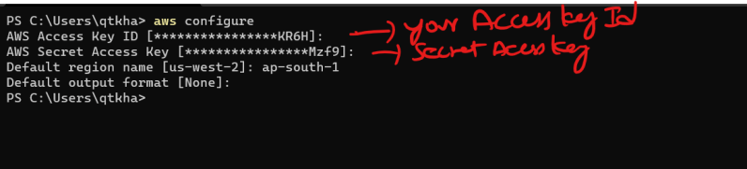
* Install eb cli <https://docs.aws.amazon.com/elasticbeanstalk/latest/dg/eb-cli3-install.html>
* For manual installation <https://docs.aws.amazon.com/elasticbeanstalk/latest/dg/eb-cli3-install-advanced.html>
* Lets create a python flask application
* Follow the class room video to view how to create and deploy a python flask application
* references in other languages

.NET <https://docs.aws.amazon.com/elasticbeanstalk/latest/dg/create_deploy_NET.html>

Java <https://docs.aws.amazon.com/elasticbeanstalk/latest/dg/create_deploy_Java.html>

Node Js <https://docs.aws.amazon.com/elasticbeanstalk/latest/dg/create_deploy_nodejs.html>

Python <https://docs.aws.amazon.com/elasticbeanstalk/latest/dg/create-deploy-python-apps.html>

Docker <https://docs.aws.amazon.com/elasticbeanstalk/latest/dg/create_deploy_docker.html>